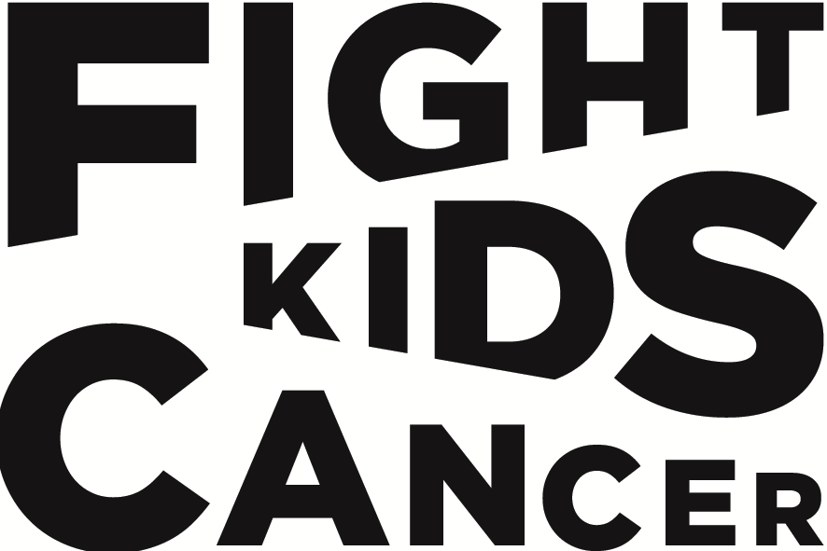
2026-2027 FIGHT KIDS CANCER Call for Proposals
Expression of Interest - Clinical Trials
Applications deadline: 13th October 2026 16:00 (CEST, UTC+2)

IMPORTANT NOTES:
• Complete all shaded fields marked as "online only" directly in the portal
• Refer to Annex C (Guidelines) for detailed completion instructions
Part 1: Proposal Summary
Information | Requirement
Project Title | please fill in
Project Acronym | please fill in
Project duration (months) | online only

Part 2: Lead PI details
Information | Requirement
Last (family) name | please fill in
First (given) name | please fill in
Title (Ms, Mr, Dr, etc.) | please fill in
Institution name | online only
Department | online only
Country | online only
Email address | online only
Phone number | online only
Details of each Co-Investigator collaborating on the project
Name (s), Institution(s) and country | online only

Part 3: Budget details
Information | Requirement
Total project budget | online only
Grant requested from FKC | online only
Confirmed co-funding sources specifying amount and funder’s name (if applicable) | online only

Part 4: Project summary
Information | Requirement
Briefly describe your proposed research in clear, concise language (max. 250 words) | online only
Keywords (max. 5) | online only
Has this project been previously submitted to the FKC funding programme? If YES, please provide last year’s EoI application number | online only

Part 4: Case for support
Describe your proposed research, including:
1. Research objectives
2. Implementation of the science/methodology
3. Expected impact and outcomes
(max. 1200 words)

Please fill in

Part 5: Expertise of the consortium
Biosketch* of the lead PI
Describe PI expertise and track record, including 3-5 key publications
demonstrating academic excellence and research impact. (max. 200 words, publications not included in word count)

Please fill in

Biosketch(es)* of the co-PI(s)
Describe the expertise and track record of each co-PI, including 3-5 key publications
demonstrating academic excellence and research impact. (max. 200 words, publications not included in word count)

Please fill in

To be completed online only:
By ticking this box, you confirm that you understand and accept that your clinical trial project may be funded in two successive phases, depending on the success of the initial stage. In such a case, you will need to submit the proposal for the next phase directly to the “full application” stage in a later call (bypassing the “expression of interest” stage).
This clinical trial can be structured in two or more distinct phases - where the success of an initial phase determines the feasibility of subsequent ones and the applicants acknowledge the possibility that the Committee considers it in FIGHT KIDS CANCER’s best interest not to commit the full requested amount upfront.

* A biosketch is a streamlined version of your CV.
This form should be uploaded in PDF format on the submission platform no later than 16:00 (CEST, UTC+2) on 13th October 2026.

