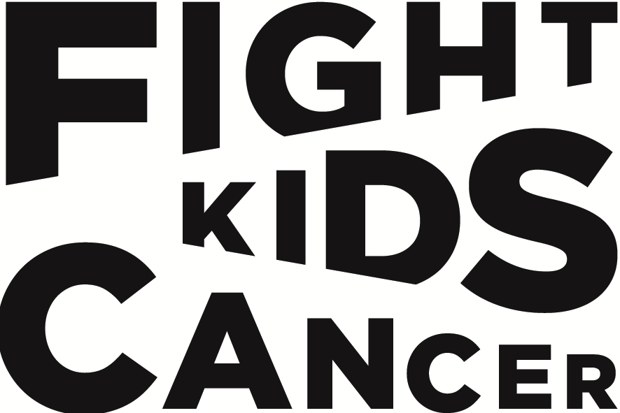
2026-2027 FIGHT KIDS CANCER Call for Proposals
Expression of Interest – Translational Research
Applications deadline: 13th October 2026 16:00 (CEST, UTC+2)

IMPORTANT NOTES:
• Complete all shaded fields marked as "online only" directly in the portal
• Refer to Annex C (Guidelines) for detailed completion instructions
Part 1: Proposal Summary
Information | Requirement
Project Title | please fill in
Project Acronym | please fill in
Project duration (months) | online only

Part 2: Lead PI details
Information | Requirement
Last (family) name | please fill in
First (given) name | please fill in
Title (Ms, Mr, Dr, etc.) | please fill in
Institution name | online only
Department | online only
Country | online only
Email address | online only
Phone number | online only
Details of each Co-Investigator collaborating on the project
Name (s), Institution(s) and country | online only

Part 3: Budget details
Information | Requirement
Total project budget | online only
Grant requested from FKC | online only
Confirmed co-funding sources specifying amount and funder’s name (if applicable) | online only

Part 4: Project summary
Information | Requirement
Briefly describe your proposed research in clear, concise language (max. 250 words) | online only
Keywords (max. 5) | online only
Has this project been previously submitted to the FKC funding programme? If YES, please provide last year’s EoI application number | online only

Part 4: Case for support
Describe your proposed research, including:
1. Research objectives
2. Implementation of the science/methodology
3. Expected impact and outcomes
(max. 1200 words)

Please fill in

Part 5: Expertise of the consortium
Biosketch* of the lead PI
Describe PI expertise and track record, including 3-5 key publications
demonstrating academic excellence and research impact. (max. 200 words, publications not included in word count)

Please fill in

Biosketch(es)* of the co-PI(s)
Describe the expertise and track record of each co-PI, including 3-5 key publications
demonstrating academic excellence and research impact. (max. 200 words, publications not included in word count)

Please fill in

* A biosketch is a streamlined version of your CV.
This form should be uploaded in PDF format on the submission platform no later than 16:00 (CEST, UTC+2) on 13th October 2026.

